Instructions for Experiment with Digital Rear-View Mirrors

Background
Welcome to our experiment on Camera Monitoring Systems (CMS) for cars. These systems replace conventional physical rear-view mirrors with digital cameras and displays. An example is shown below.

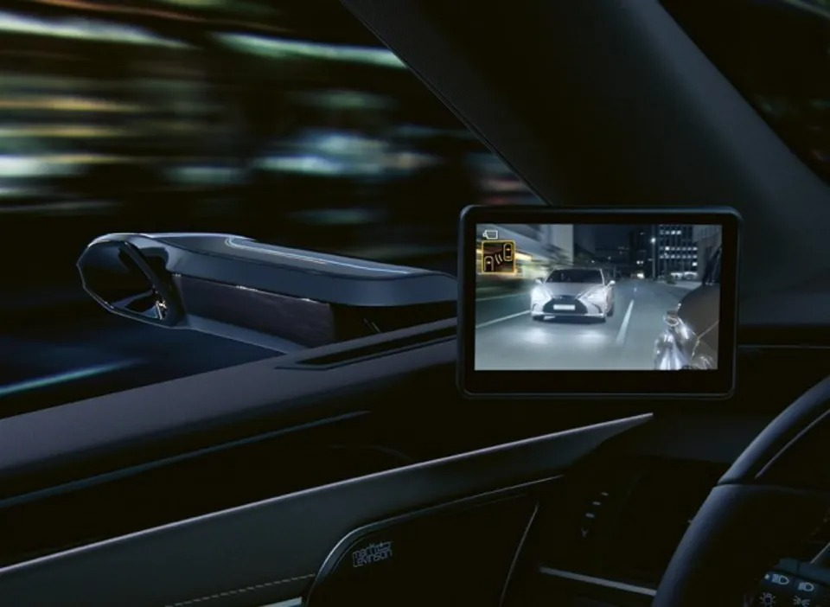

In this experiment, you will interact with a simulated driving environment using a CMS to help us understand how people perceive their surroundings in different driving situations and how they might react to certain disturbances that can arise, for example due to technical reasons.

You will participate in a driving situation with pre-recorded video clips while sitting in front of a TV screen that simulates a car windshield. In the bottom left corner of the screen, an image corresponding to the left side mirror will be displayed. See example image below.

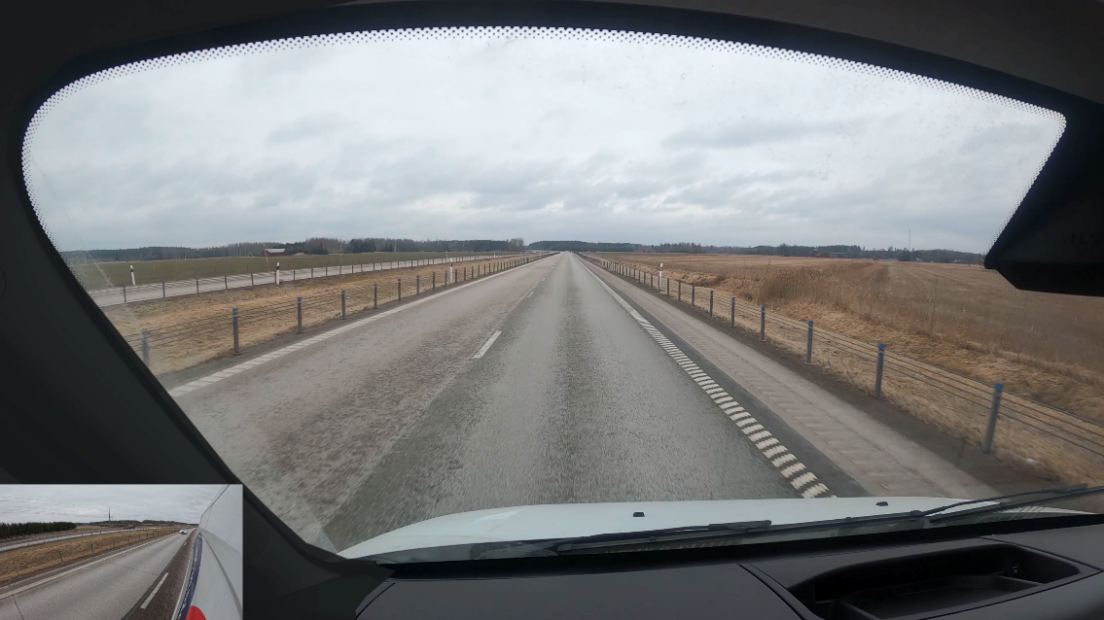

FORWARD VIEW

SIDE MIRROR

In the simulation, you will drive the following van that is approximately 6 meters long.



In some scenarios, the CMS display may show different levels of visual flickering. This is intentional and part of the experiment. Please perform the task as naturally as possible.

During the experiment, an eye-tracking system will record your eye movements to study visual attention during the task. Please be mindful of the eye-tracker’s head-tracking range. Avoid moving your head excessively and ensure that your eyes are not obstructed (e.g., by your hands or hair) so the system can maintain a clear line of sight.

The total duration of the experiment, including instructions, practice trials and short breaks, is approximately 60 minutes.

Task Description: Last Safe Gap (LSG)
The purpose of the task is to determine the last safe moment to change lanes before an approaching vehicle passes your car.

Task description:
1. Look ahead: Each trial begins with the forward view showing you driving on a highway. Your task is to follow the road ahead by steering with the steering wheel and keeping your foot on the accelerator. It is important that you follow the road as closely as possible, as in a real driving situation, and pay attention to both the road ahead and the side mirror. During the experiment, please keep your hands on the steering wheel at all times.

2. Audible signal:
At a certain moment during the video, you will hear an audible signal indicating that there is an obstacle ahead in your lane.
From the moment you hear the audible signal, you should start judging when it is still safe to change lanes. Continue steering the car while paying attention to the side mirror and the approaching vehicle behind.

3. Safe lane-change assessment: After hearing the audible signal, your task is to determine the last moment when it is still safe to change lanes before the approaching vehicle reaches you. Press the left paddle behind the steering wheel at this moment. The exact moment you press the paddle will be recorded instantly. After the video clip, you will indicate how confident you are in your decision and rate the visual comfort of the display. Once you click "OK" on the rating scales, you cannot go back to change your answer. Please ensure that you are certain of your choice before proceeding. Your answer will be recorded digitally.

4. Repetition: Points 1–3 is repeated for a total of 30 different video clips. After completing all scenarios, the experiment ends.

5. Break time: When the "Break" message pops up, you are welcome to leave your seat and the lab room, have a cup of coffee, and take a five-minute break before returning to the lab to continue the experiment.
_________________________________________________________________________

Training: Before the experiment, you will be given two practice rounds to familiarize yourself with the task. During the training, you are welcome to ask questions to the test leaders. After the practice rounds, the test leaders will start the experiment and leave the room.

Generally

- Set the moment for safe lane changes based on your own perception and driving style. There is no predetermined "right" time; we are interested in your intuitive and personal judgment.
- Even if you feel that the last safe time for lane changes has been passed, it is better to press "late" than not to press at all.
- If you feel the need to rest your eyes or take a moment between trials, it is possible to take a mini break without pressing "OK" after completing a rating scale.
- If you have any questions or concerns now before the experiment, do not hesitate to notify the test leaders. If problems arise, the test leaders are available outside the room; otherwise, communication should be avoided during the experiment.
- Your participation is voluntary, and you can choose to discontinue participation at any time.

If you feel ready, please let the test leader know and we will begin the practice sessions for the experiment. Thank you again for your participation!

